
Package Request Form Windows
Version 5.9
HCL – Application Packaging Factory

Contents
1. Introduction 3
2. Application Information* 3
3. Software and Hardware Dependencies 3
4. Package Information / Customization details 4
5. License Information 4
6. Installation and Configuration Steps* 5
7. User Defined Test * 5

Introduction

In order to correctly package an application, a certain amount of information is required. This form details the information requirements and needs to be filled in before packaging of an application can commence. Basic instructions are provided below.

Please note: Sections marked with asterisk (*) symbol are mandatory.

Application Information

Application Name* | Mozilla Firefox
Application Manufacturer* | Mozilla
Application Version* | 91.6.0
Application Description*  State few lines explaining benefits to end users. | It is a free and open-source web browser developed by the Mozilla Foundation
Application Icon*  It is required to provide icons for the application provided by the vendors, to update the same in Software Center. Please provide clear picture in .jgp or .png format. | 
Type of Request*  New – new request for this platform  Upgrade – upgrade of a previous app  Coexist – coexisting with a previous version  Specify the previous application for Upgrade and Coexist alternatives  Please Note: For AppV packages the upgrade is not handled | Upgrade  Below previous versions should be uninstalled from the machine and upgraded with this latest version i.e. 91.6.0  Mozilla_FirefoxESRConfig_60.8_v1.0  Mozilla_FirefoxESRConfig_68.2.0  Mozilla_FirefoxESRConfig_68.4.1  Mozilla_FirefoxESRConfig_68.5.1  Mozilla_FirefoxESRConfig_68.7.1  Mozilla_FirefoxESRConfig_68.10.0  Mozilla_FirefoxESRConfig_78.4.0  Mozilla_FirefoxESRConfig_78.4.1  Mozilla_FirefoxESRConfig_78.9.0  Mozilla_FirefoxESRConfig_78.11.0  Mozilla_FirefoxESRConfig_78.14.0  Mozilla_FirefoxESRConfig_91.4.0  Mozilla_FirefoxESRConfig_91.5.0
Screenshot from Program and Features
It is feasible to provide the screenshot from the Add & Remove Programs.
Application Categorization*  Applications deployments are now in PULL strategy i.e The user will have to download the application from Software Centre / Company Portal if it is a first time installation. For the application already present in user's machine, it be updated automatically. In context to this, the applications have been further categorized in to three categories:  Core Applications: Applications which will be a part of Operating System deployment and which comes with new devices.  Managed Applications: Applications which are either licensed or are deployed to certain set of users, or both.  Universal Applications: Commonly used applications like Chrome, Firefox, 7zip, etc which are deployed or made available for all the users in the environment. | Managed Applications  Note: Please select your applications based on the nature of your applications. If your applications should be part of all image, please select core. . If your applications are licensed or critical to specific target group please select Managed Applications. If your applications can be used by anyone, please select Universal.  For, eg, BOPO applications can be selected as Managed Applications.

Please note that the uninstallation package will automatically remove any application version below N-2 after 90 days of release of Nth version of application
Requestor must inform the application users to install the latest version in order to avoid the sudden removal.

Example: V1.6 is requested for roll out
- 01 Jun 2021: Application V1.6 is rolled out in production
- Post 90 days on or after 30 Aug 2021: Application Version below N-2 will be uninstalled from user devices. In this case, V1.3 or below

Software and Hardware Dependencies

Please specify the software and hardware requirements of the application. Please include any applications that the application is dependent upon and/or integrates with.

Software*
Type of software | ____________________________
Dependencies and Integrations  List known Integrations or Dependencies with or to other Applications | Integrated with HM Firefox Config 4.41 (Updated One)  HM Firefox Config should be updated with latest one
Pre-requisites  Specify Pre Requisites (components) that are required in order for the application to install & run (i.e. ODBC, .NET framework, JRE Runtime etc.) | HM Firefox Config 4.41 must be installed on the machine, this should not be a dependency that installs automatically but just set as a requirement for the deployment to run.
Restart Option* | Note: Please Select either of this check box
Note: If Restart Option is Yes please mention the reaon.
Hardware, If any
List Hardware Dependencies

Package Information / Customization details

Application Type*
Browser Based Applicaton*
(Microsoft Edge Chromium is the primary browser, if application is selected for other browser mention the reason)
Note: As there is no premium support for Firefox and Chrome so any issues with these browsers can be supported in best effort basis.
Package Request Type (Optional)
Package type will be decided on the basis of ACT report generated by HCL. Please make selection in case you have specific requirements.
Target Operating System * | Specify the OS version based on its compatibility ________________________________
If your selecting Windows 10 as Target Operating System than select the device type * | Note: By default all the applications will not be deplyod on VDIs from now onwards unless it is specified in PRF. This is to avoid the cost involved in Azure as all the VDIs are soon going to be running on Azure.
Target Audience for the application
Select if Core or Normal Application *
If your application is core application please select whether a separate deployment would be required in addition to make it a part of OS imaging Task Sequence.
Language*  What language setting should be used in the application | ________________________________
Customization Details
E.g. any customization is needed in the package, like adding any proxy settings, home page etc.
Please specify the path for the installation directories & other file systems that is going to be created after application installation, if any.
Application Severity * | Note:Super Express Request is only for BOPO request.
Reason for Express*
(Mention the business reason for creating the Expresss request)
Upgrade mode*  If previois version of application already exists in your system, you will receive this upgrade. | Specify the Days or Weeks____________________________________  Note: Please Select either of this check box
New system installation mode *
If your application is not rolled out in the environment previously than you have to select one option.
During Installation, If application is running in the backend? *

License Information

Please specify the Application license information:

Licensed to | H&M AB
License is required
License Type *
Specify if the license is per device or per user
License source
Enter license key or source to license file or server

Installation and Configuration Steps*

Please detail full installation steps, including all options selected and the configuration required. This will dictate how the installation is performed, setup and finally runs.
Note: Please provide the installation and configuration steps from the raw media (vendor installer).Preferable doc and pdf documents.

 | Screenshot | Input
MSI Windows 10
Run the following command where the <full path to folder> variable has been substituted for the full path to the folder containing the source files
<current version of firefox setup.exe> /INI="<full path to folder>\setup.ini"
Setup has completed when the .exe file is not longer present as a process in the Task Manager
 |  | Copy the files from the Mozilla Firefox ESR folder in the .zip to the main installation directory
 |  | Create a shortcut to the Firefox executable from the Mozilla Firefox package, name it “Mozilla Firefox ESR v(version number)” (ex. Mozilla Firefox ESR v68.4
 |  | InstallDirectoryPath=C:\Program Files (x86)\Mozilla Firefox ESR
 |  | Auto-update should be suppressed

User Defined Test *

Please provide validiation steps so that packaging team can ensure that package is created as per the requirement.
Please provided supported screenshots.

 | Screenshot | Input

Timeline for Application Packaging Service
Depending on urgency, two different options for Application Packaging can be chosen. Both options are described below.

Normal Packaging
Timeline for packaging when using Normal service:
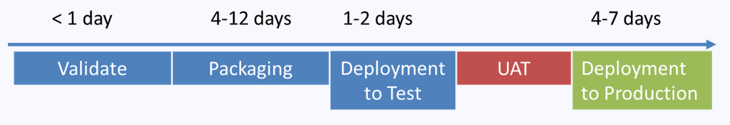
Packaging time varies as follows depending on the complexity of the package.
Simple: packed within 4 Days
Medium: packed within 8 Days
Complex: packed within 12 Days
Express Packaging​
Timeline for packaging when using Express service: 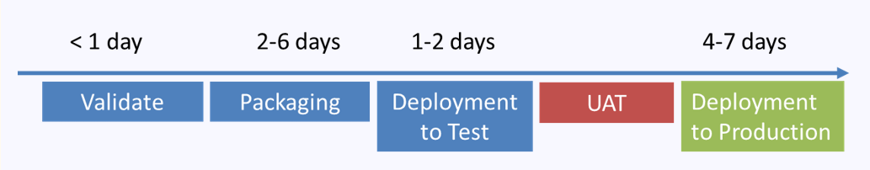
Packaging time varies as follows depending on the complexity of the package.
Simple: packed within 2 Days
Medium: packed within 4 Days
Complex: packed within 6 Days

Super Express Packaging
Timeline for packaging when using Super Express Service (BOPO only):

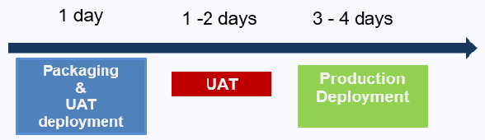
Simple: packed within 1 Day

Note: This is only for BOPO packages only, also package which will be categorized as SIMPLE in BOPO will be considered in Super Express.
Glossary

Contact Details

Owner The business contact who is responsible for the evolution of the application within the business

Technical Support Rep Could be the application developer, someone who is familiar with how the application is set up, i.e. installs details, database connectivity. Someone who knows what to do if the application is not working

Requirements & Dependencies

Software Any applications or files and their locations required for the application to run
Hardware This includes but is not limited to access to dongles, scanners, printers, memory, hard disk space, etc.
Infrastructural These can be some network dependency, this is the middleware required to
run the application, i.e. network
Or back-end databases, ODBC information, etc.

License Information The serial numbers required to setup or run the application, if it is a single user or a site license, dongles, licenses servers, etc.

Installation and
Configuration Steps A set of step by step instructions to follow during the application setup routine.

